Corner of Broadway and Norfolk
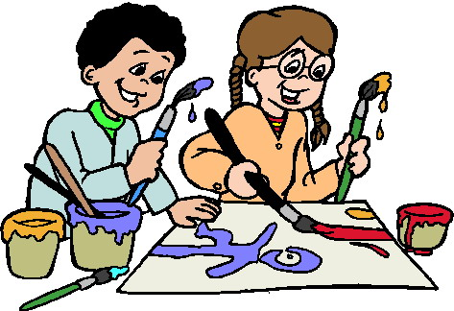
July 10th to August 9th, 2018
10 a.m. to Noon

Tuesday, July 10th  Welcome to Summer Arts & Crafts  Come for some arts and craft activities and see what we have planned for the summer | Wednesday, July 11th  Silly Sally  Bubble Fun  Art Activity: | Thursday, July 12th  Talking Hands Theater  2 Dinosaurs are better than 1  Art Activity:
Tuesday, July 17th  *Lucy Kalantari & the Jazz Cats  The Cambridge Arts  Performance starts at 10 a.m. | Wednesday, July 18th  Jafar Manselle  African Drumming  Art Activity: Drum Making | Thursday, July 19th  Marcie Joy  Music with Marcie  Art Activity: Music Shakers
Tuesday, July 24th  Angelique Smith  “Hip Hop You Don’t Stop”  Art Activity: To Be Announced | Wednesday, July 25th  Terry Murray  Inventor Mentor  Art Activity: | Thursday, July26th  A Day at the Beach  Art Activity: Sand Art/Message in Bottle
Tuesday, July 31st  Silly Sally  Puppets & Magic  Art Activity: Making Puppets | Wednesday, August 1st  Summer Art Fun  Art Activity: Scenic Sunglasses & Visors: | Thursday, August 2nd  Doria Stories  Folk Tales Around the World  Art Activity: Storybook Characters Snow Globes
Tuesday, August 7th  Richard Frota  Ecology of Sound  Art Activity: Making Sounds with Recycled Material | Wednesday, August 8th  To Be Announced  Art Activity: | Thursday, August 9th  Justin Petty  Steel Drums  Art Activity: Sound making crafts

Department of Human Service Programs - City of Cambridge
Join us for an hour of Arts and Crafts, followed by a performer on Tuesday & Thursday.
In case of in climate weather all activities will be cancelled.
Contact Wade at 617/349-6309 for more information.

