The Haunting of Russell Haunted House
October 26 from 5-6:30pm
Address: 680 Huron Avenue
This event is open to Pre-Teen, Middle School, Teens & family, so please join us.
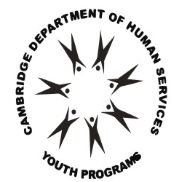
The City of Cambridge does not discriminate in providing services to youth and their families on the basis of age, race, religion, national origin, political belief, sexual orientation, marital status, or disability. The Department of Human Service Programs will provide auxiliary aids and services, written materials in alternative languages, and reasonable modifications in policies and procedures to qualified individuals upon request. TTY/TDD (617) 492-0235.

Sponsored by Cambridge Youth Programs and Hosted @ the Russell Youth Center
For more information please contact Greg @: 617-349-6314

