Resources

Local LGBTQ+ Resources

BAGLY (Boston Alliance of Gay, Lesbian and Transgender Youth)
www.bagly.org
PO Box 814
Boston, MA 02103
617.227.4313
Youth group meets weekly and sponsors events. Gay group which is especially welcoming to transgender kids.
Bisexual Resource Center
www.biresource.org
PO Box 400639
Cambridge, MA 02140
617.424.9595
Resource center for bisexuals, including youth and adults. Also sponsors events and discussion groups.

Boston GLASS (Gay and Lesbian Adolescent Social Services)
www.jri.org/services/health-and-housing/health/boston-glass
93 Mass. Ave., Floor 3
Boston, MA 02116
617.266.3349
Drop-in center for LGBTQ+ youth (ages 13-25) offering support and culturally sensitive resources.

Cambridge LGBTQ+ Commission
www.cambridgema.gov/Departments/LGBTQPlusCommission
The GLBT Commission meets on the fourth Thursday of every month (except August and December), from 5:30 - 7:30PM at Windsor Street Community Health Center, 2nd Floor Conference Room, 119 Windsor St., Cambridge. Meetings are open to the public.

Familia Es Familia
www.familiaesfamilia.org
Support and resources among for acceptance of gay and lesbian family members in Latino communities (currently English language only).

Fenway Community Health Center, Lesbian/Gay Family and Parenting Services
www.fenwayhealth.org
7 Haviland St.
Boston, MA 02115
617.927.6243
Comprehensive health care in a welcoming environment.

Gay and Lesbian Advocates and Defenders (GLAD)
www.glad.org
294 Washington Street; Suite 740
Boston, MA 02108
617.426.1350
New England legal rights organization dedicated to ending discrimination based on sexual orientation, HIV status and gender identity and expression.

Gay, Lesbian, and Straight Education Network (GLSEN)
www.glsen.org/boston
132 Boylston Street, 4th Floor
Boston, MA 02116
617.451.1119
National organization making schools safer for ALL students, regardless of sexual orientation or gender identity/expression.
Gender Spectrum
www.genderspectrum.org
Helping to create gender sensitive and inclusive environments
for all children and teens.

Greater Boston PFLAG (Parents and Friends of Lesbians and Gays)
www.gbpflag.org
P.O. Box 541619
Waltham, MA 02454-1659
Waltham Office: 781.891.5966
Provides training, resources and opportunities for dialogue about sexual orientation and gender identity, and acts to create a society that is healthy and respectful of human diversity.

I AM: Trans People Speak
www.transpeoplespeak.org
Trans people, family members and allies tell their stories to raise awareness about the diversity that exists within transgender communities.

Massachusetts Transgender Political Coalition (MTPC)
www.masstpc.org/tp
Dedicated to ending discrimination on the basis of gender identity and gender expression.
Trans Youth Family Allies
www.imatyfa.org
Empowers children and families by partnering with educators, service providers and communities, to develop supportive environments in which gender may be expressed and respected.

Additional Resources

How to Start a Gay-Straight Alliance
www.aclu.org/video/how-start-gay-straight-alliance?redirect=lgbt-rights/how-start-gay-straight-alliance
A short online video outlining the steps students can take to start a GSA at any public school (can be used in out-of-school time programs).

GLSEN “Changing the Game”
www.glsen.org/participate/programs/changing-the-game
For sports. This project gives ideas for students and parents to take steps within their own schools to make school sports a more inclusive, safe space for LGBTQ students, including resources on Title IX as it relates to the protection of transgender athletes.

GLSEN Ready, Set, Respect! Elementary Toolkit
www.glsen.org/readysetrespect
The kit provides a set of tools that will help you prepare to teach about respect and includes lesson plans that can help you seize teachable moments. The lessons focus on name-calling, bullying and bias, LGBT-inclusive family diversity and gender roles and diversity and are designed to be used as either standalone lessons or as part of a school-wide anti-bias or bullying prevention program.

GLSEN “Safe Space Kits”
www.glsen.org/safespace
Designed to help you create a safe space for LGBTQ youth in schools, the Safe Space Kit is GLSEN’s Guide to Being an Ally to LGBTQ Students. The guide provides concrete strategies that will help you support LGBTQ students, educate about anti-LGBTQ bias and advocate for changes in your school.

Teaching Tolerance
www.tolerance.org/magazine/tips-for-teachers-ally-yourself-with-lgbt-students
Tips for teachers to ally yourself with LGBTQ+ students

The Trevor Project
www.thetrevorproject.org
The Trevor Project is the leading national organization providing crisis intervention and suicide prevention services to lesbian, gay, bisexual, transgender and questioning (LGBTQ) young people ages 13-24.

Youth in Motion
www.frameline.org/distribution/youth-in-motion
Provides free LGBTQ themed movies, with professionally created curricula and action guides, to student clubs and educators in middle and high schools.

Bullying Prevention Resources

Education.com
www.education.com
Bullying at school and online video clips, activities, information and discussion about a variety of aspects of bullying. Includes Spanish translations of many resources.

The Kinder and Braver World Project
www.education.com/topic/school-bullying-teasing
Current research related to youth meanness and cruelty.

Massachusetts Aggression Reduction Center (MARC)
cyber.law.harvard.edu/node/7491
Includes links to research and free resources for educators and parents. Evidence based and evaluated annually.

Stop Bullying Now
www.stopbullying.gov/index
Presents practical research-based strategies for reducing bullying in schools.

Gender Identity Youth Literature Available at the Cambridge Public Library

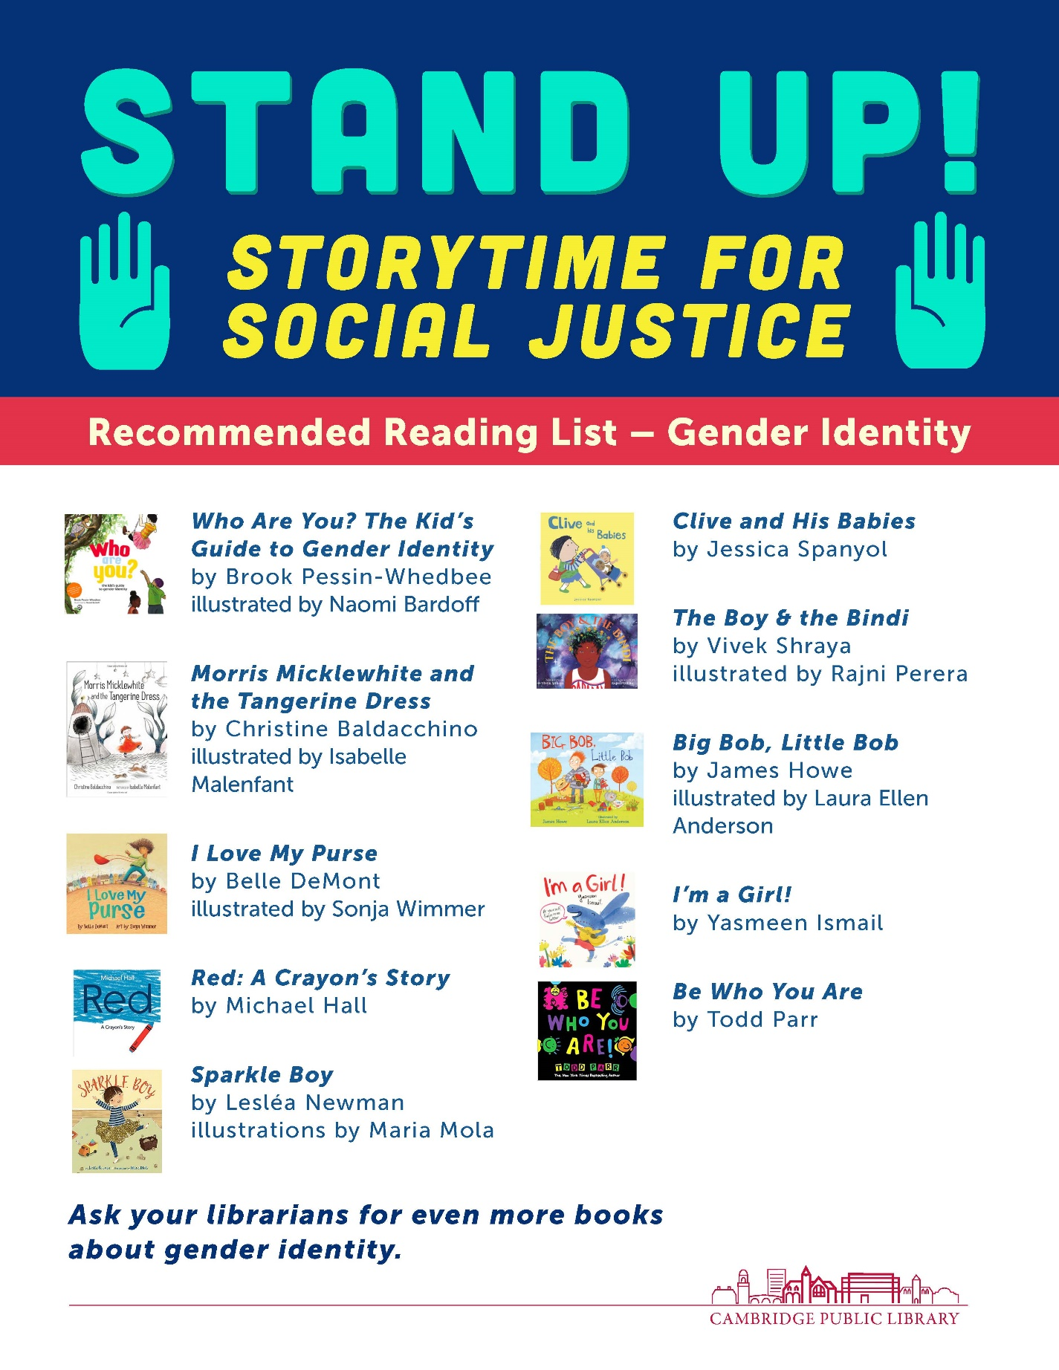

LGBTQ+ Literature for Grades 9-12 Available at the Cambridge Public Library

The Upside of Unrequited
By Becky Albertalli

Georgia Peaches and Other Forbidden Fruit
By Jaye Robin Brown

Look Both Ways
By Alison Cherry

Jess, Chunk, and the Road Trip to Infinity
By Kristin Elizabeth Clark

Little & Lion
By Brandy Colbert

Labyrinth Lost
By Zoraida Cordova

Of Fire and Stars
By Audrey Coulthurst

Dreadnought
By April Daniels

Look Past
By Eric Devine

The Love Interest
By Cale Dietrich

The Cursed Queen
By Sarah Fine

Girl Mans Up
By M.E. Girard

Whatever
By S.J. Goslee

Been Here All Along
By Sandy Hall

We Are the Ants
By Shaun David Hutchinson

Run
By Kody Keplinger

Read Me Like a Book
By Liz Kessler

Honestly Ben
By Bill Konigsberg

Radical
By E.M. Kokie

We Are Okay
By Nina LaCour

Goldie Vance
By Hope Larson, Brittney Williams, et al.

Not Your Sidekick
By C.B. Lee

The Gentleman’s Guide to Vice and Virtue
By Mackenzi Lee

True Letters from a Fictional Life
By Kenneth Logan

10 Things I Can See From Here
By Carrie Mac

When the Moon Was Ours
By Anna Marie McLemore

It Looks Like This
By Rafi Mittlefehldt

*More suggestions available at the Cambridge Public Library Main Brain Teen Room

