UNEMPLOYMENT AND WORKER ASSISTANCE

You can now apply for Unemployment Insurance or Pandemic Unemployment Assistance. If you don't know where to start, apply for UI benefits first. If you don't qualify, try applying for PUA.
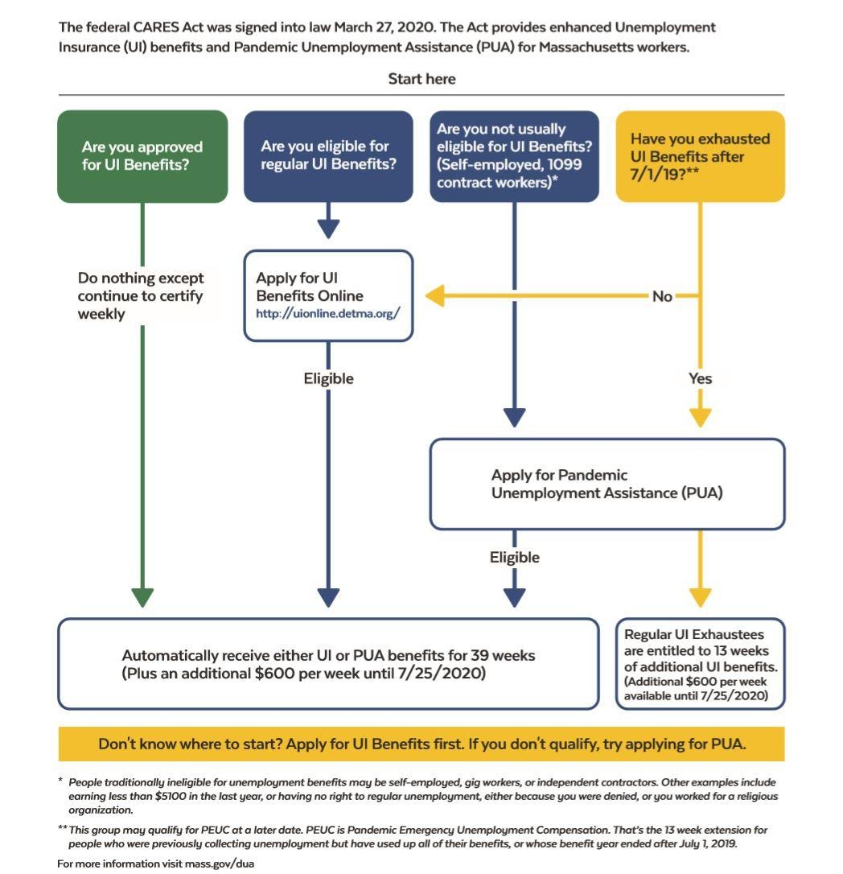

Apply for Unemployment Insurance
Filing Online
- This is the fastest way to file a claim. Apply for unemployment insurance online by visiting this website. You must file for benefits using your employer’s exact name as it is stated on your W-2.
- If you have filed a UI claim within the past 52 weeks, you do not have to file a new claim. You will be able to reopen your prior claim.
- Click here for instructions on how to apply, or, here for step-by-step screenshots of the unemployment application process. You can also sign up for a virtual town hall presentation on applying for unemployment assistance.
- If you have trouble logging in to the online claim system or need to make a change to your application, schedule a call back from the MA Department of Unemployment Assistance (DUA) by filling out this form.

Filing by Phone
- You can file an unemployment claim by phone, but expect long wait times due to the recent surge in claims. Hours are Monday to Friday from 8:30am-4:30pm and Saturdays from 8am-12pm. Contact the TeleClaim Center at: 877-626-6800.
- You can also schedule a call back from the MA Department of Unemployment Assistance (DUA) by filling out this form.
- Greater Boston Legal Services is also offering free assistance with online claims. Click here for more information. Not on Find It, probably worth making a page

Language Support for Unemployment Claims
- The Baker-Polito Administration launched a Spanish language online application for those who need to apply.
- Language services are available through the TeleClaim Center upon request. Multilingual agents are available by calling: 877-626-6800.

Changes to Unemployment
- DUA will now pay workers who are ordered to quarantine themselves or leave work because of risk, exposure, or infection will be paid.
- People will also be paid if leaving work to care for a family member.
- While employees are still asked to work when able, they will not need to provide any medical documentation for their leave.
- Some requirements around current unemployment claims have been relaxed, allowing many workers who are affected by closures to get some relief faster.
- The one-week waiting period for unemployment benefits has been waived as of March 18, effective immediately, allowing new unemployment claims to be paid more quickly.
- An additional $600 per week for individuals receiving unemployment compensation is being implemented by DUA. The additional $600 will be added to unemployment benefits retroactive to March 29, 2020. More info here.
- You are still required to certify weekly to receive your payments. You can do this online by logging in to your online UI account or by calling 617-626-6338. You must make a request even if your eligibility is still being decided or you have an appeal pending. If you are approved for benefits, you will only receive payment for the weeks you’ve requested.
- To select or reset your DUA 4-digit Personal Identification Number (PIN) call 617- 626-6943.
- Answers to frequently asked questions about filing for unemployment during the COVID-19 emergency.

Pandemic Unemployment Assistance
- Pandemic Unemployment Assistance (PUA) provides up to 39 weeks of unemployment benefits to individuals who are unable to work because of a COVID-19-related reason, but are not eligible for regular or extended unemployment benefits (self-employed, independent contractors, workers with limited work history, and others). Apply online by visiting this website.
- Click here to check your eligibility for PUA.
- For more information on eligibility, please view our Pandemic Unemployment Assistance Guide. Instructions are also available in Spanish.

