Attention Cambridge 5th & 6th Grade Parents
Announcing the Return & Registration For The
Greater Boston Social Dance Program - Cambridge
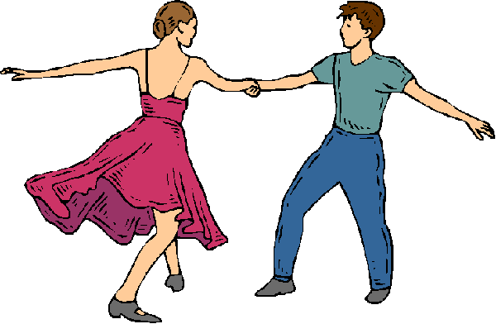
Enrollment for the Spring 2023 Season

Classes Begin Monday, April 3
After a three year break due to the pandemic, the Greater Boston Social Dance Program is beginning again in Cambridge. The social dance program is a series of classes that helps children develop social skills in formal and informal settings. By learning and more importantly, practicing their social etiquette, our students walk away with great confidence by knowing what to do, not only in the ballroom, but in all situations in life. Students will learn the importance of a firm handshake, eye contact, posture, confidence, making a good first impression, standing as a sign of respect, everyday etiquette tips, escorting and seating partners and the importance of conversation.
All of these skills are taught through Ballroom Dancing. Students will learn a variety
of Ballroom and line dances including Fox Trot, Swing, Slap Leather, Disco and many more.

Classes are held at the Holy Trinity Armenian Church
145 Brattle St, Cambridge, MA 02138
Monday afternoons from 4:15 – 5:30 PM
Classes are held on April 3, 10, & 24 May 1, 8 & 15.
Subscription cost is $205.00 per child. Second child (twin) is $105.00
To register your child please go to our website: www.gbsocialdance.com
(Select the enrollment tab at the top – choose CAMBRIDGE)
FOR QUESTIONS, CONTACT
Parent Représentatives
Lisa Natale – lnatale88@gmail.com
Or
Douglas Trudeau – Program Director – wellsdance@outlook.com

Refund Policy
Refunds will be issued under the following conditions:
- We understand that schedule conflicts can come up before the start of the first class. Therefore, you can cancel your subscription up to one week prior to the start of the first class and receive a 100% refund (less $5.00 processing fee). If cancellation occurs during the startup week, a $50 cancellation fee will be charged.
- Cancellation after the start of the session will be issued as follows:
  - After Class One 60% refund
  - After Class Two 50% refund
  - After Class Three – Eight No refund
- A refund will be issued due to injury or illness. A doctor’s note is required. The refund will be pro-rated based on the numbers classes attended or 100% if prior to the first class.
- Refunds due to an extenuating circumstance can be requested by emailing Douglas Trudeau at: wellsdance@outlook.com

Terms & Conditions
I have chosen to have my child participate in the social dance program run by Douglas Trudeau and his company Showstoppers, Inc. dba as Greater Boston Social Dance - Cambridge.
I attest that my child is in proper physical condition and capable of participating in the related activities and I agree to release , hold harmless and discharge Showstoppers, Inc. and their contracted workers from all claims, cost, liabilities expenses or judgments including attorney’s fees and court cost for any occurrences in connection with any instruction.
I hold Showstoppers Inc. and its owners and employees free from liability for any injury sustained by my child while he or she is enrolled in any instruction, including all risks reasonably connected with such activity whether foreseen or unforeseen.
I understand that Showstoppers Inc. is not responsible for any child who is left unsupervised in the common areas and parking lots.
Showstoppers Inc. is not responsible for any lost property.
Showstoppers, Inc. may use photographs, videos or likeness of my child as needed for its record-keeping, advertising and public relations.

