
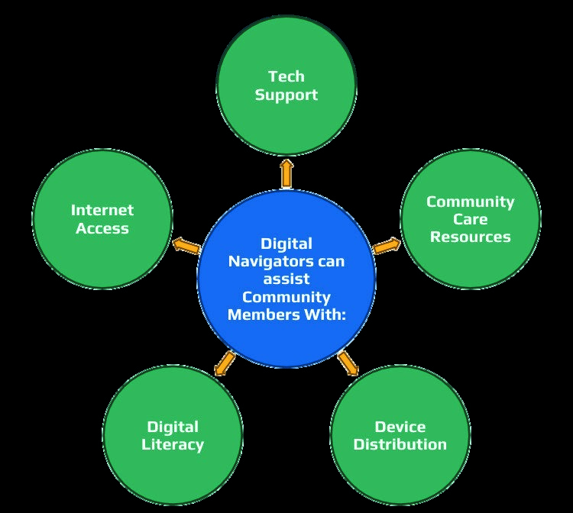
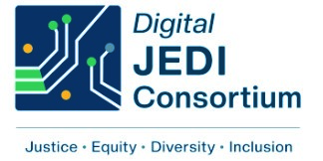
EMPOWER YOUR
DIGITAL JOURNEY:
FREE HELP FROM
DIGITAL NAVIGATORS

BENEFITS TO
THE COMMUNITY
Stay connected with family and friends

Access vital information and services online

Enhance your digital skills for better
opportunities

Find resources
Or visit this website & click GET HELP:
https://massdigitaljedi.org/
WHAT IS A

DIGITAL NAVIGATOR?
DIGITAL NAVIGATORS PROVIDE ONE-
ON-ONE SUPPORT TO HELP YOU
ACCESS THE INTERNET, SET UP
DEVICES, AND USE ONLINE SERVICES
EFFECTIVELY. OUR MISSION IS TO
BRIDGE THE DIGITAL DIVIDE IN OUR
COMMUNITY.
LIST OF SERVICES
WE PROVIDE

HELP WITH USING SMARTPHONES,
TABLETS, AND COMPUTERS
GUIDANCE ON ACCESSING ONLINE
SERVICES (HEALTHCARE, JOB
APPLICATIONS, HOUSING,
EDUCATION)
SAFETY TIPS FOR ONLINE PRIVACY
AND SECURITY

Ready to get started?

Call us today and start your digital journey:

1-888-551-2167

